Melbourne’s Annual Water Outlook 2026
  - December 2025

Acknowledgement
We respectfully acknowledge the Traditional Owners of the Greater Melbourne region as the original custodians of this land and water upon which we rely and operate. We recognise their continuing connection to land, waters and culture.
In the spirit of reconciliation and recognition of First Peoples water knowledge and values, we remain committed to genuinely partnering with the Bunurong, Djaara, Gunaikurnai, Taungurung, Wadawurrung and Wurundjeri Woi Wurrung Traditional Owner groups and all First Peoples. These partnerships will ensure ongoing contribution of Traditional Owners to the future of water management while maintaining cultural and spiritual connections.

Summary

Current snapshot

2025 in review
- From July 2024 to June 2025, Melbourne’s water catchments recorded 305 billion litres of inflows into the four major storages, which is 36% below the 30-year average.
- Only 60 billion litres of inflows were recorded from January to June 2025, the lowest on record for this time of year.
- July 2024 was the only month in 2024/25 with above average monthly inflows. The other 11 months recorded inflows around 30-60% below the 30-year average.
- Autumn 2025 in Victoria was the hottest ever recorded.
- Total demand from the Melbourne water supply system in 2024/25, including connected regional water businesses, was 509 billion litres which is the highest since 1997/98.
- Daily water use increased, rising from 163 to 169 litres per person, the highest since 2006/07.
- Last financial year, Melbourne used 272 billion litres more water than the amount of rainwater that was captured in water storages.
- As a result of low inflows and higher water use, our storages saw the steepest decline since the Millennium Drought.
- We’ve connected nearly 38,000 new households across Greater Melbourne this year (2024/25).

Current
- Storage levels are at 75.1%.
- That’s 13.2% (239 billion litres) lower than the same time last year.
- A 50 billion litre order of desalinated water in 2025/26 is helping to boost supplies.
- Despite improved rainfall over November, the current inflow season has been well below average. The financial year to date (July to November) inflow total was 211 billion litres. This is 33.3% below the last 30-year average for this period.
- Total demand from the Melbourne water supply system for the financial year to date is 195 billion litres (as at 30 November 2025).

The year ahead
- Permanent Water Saving Rules remain in place.
- Water restrictions are not expected, but may be needed if extreme dry conditions continue. The likelihood of water restrictions in the next 12 months is Rare (1-4%).
- Local restrictions could be needed at different times for some regions, due to local storages or operational constraints.
- The climate outlook is for warmer and slightly drier rainfall conditions
- Melbourne’s population will continue to grow, so we must continue investing in infrastructure to support this growth.
- This year we'll take steps to boost storages by ordering desalinated water and encouraging Melburnians to reduce water use and make every drop count.
- We should all aim to reduce our water usage to ensure that, on average, we're not using more than 150 litres per person per day.
Permanent Water Saving Rules are in place across the state every day of the year. With dry conditions continuing, now’s the time to ‘make every drop count’, by using water wisely. Small, everyday habits – from shortening showers to saving water in the garden – helps conserve our supplies and reduce the likelihood of restrictions.

Where Melbourne’s water comes from
Melbourne’s drinking water comes from a system of rivers and reservoirs and desalinated water from the Victorian Desalination Plant. Following delivery of this years' desalinated water order, the plant will have provided 505 billion litres of water (around one year of current supply) since 2017.
Catchment inflows into Melbourne's storages are highly variable, but on average are not enough to supply our growing population. That’s why annual desalination orders of up to 150 billion litres, water efficiency and greater use of recycled water, stormwater and rainwater, are all needed to help keep our storages high, providing an essential buffer against dry conditions and severe droughts.

Planning for Melbourne’s water needs
Water is a ﬁnite resource. With a growing population and changing climate, we must act now to protect our precious drinking water, now and into the future.
Together, the metropolitan water corporations – Greater Western Water, Melbourne Water, South East Water and Yarra Valley Water – along with regional water corporations, work hard to make sure safe and reliable water is available for all of greater Melbourne and connected regional areas. This means planning for the short, medium and long term to meet the challenges ahead.
We’re also working with the Victorian Government to plan for new water sources to meet future demand. The Victorian Government’s Water Security Plan outlines how the Victorian Government is working to meet future water demand for Greater Melbourne, Geelong and parts of Gippsland. The Plan will explore the best mix of options including water efficiency initiatives, integrated water management, replenishing water sources with purified recycled water and stormwater, and expanding desalination capacity.

The challenges we face

Growing population and water demand:
Greater Melbourne’s population is projected to double by 2070, requiring significant investment in new infrastructure.

Climate variability:
Over the past 18 months, below average rainfall and hot and dry conditions through summer and autumn, have seen a steep decline in Melbourne’s water storages. South-west Victoria has experienced persistent dry conditions for the past two years.

A changing climate:
In the long term, Victoria is predicted to become warmer and drier, with less water flowing into our dams.

Our region is changing:
We must carefully balance environmental, economic, social and cultural water needs.
Melbourne's Annual Water Outlook is released each December to outline the actions we plan to take over the next 12 months to keep Melbourne's water supplies secure. These actions are based on our Drought Preparedness Plans, as well as the Greater Melbourne Urban Water and System Strategy (GMUWSS). We also track our progress toward the GMUWSS actions.

Infrastructure investment to support growth
Our region continues to grow. Greater Western Water, South East Water and Yarra Valley Water have connected nearly 38,000 new households across Greater Melbourne this year.
To support current and future growth the Victorian Government announced its Victorian Housing Statement, committing to build new homes and connect homes to essential services more efficiently.
As both our population and water needs increase, sustained investment in infrastructure is critical to ensure that all new homes have reliable access to the essential services they depend on.

What you can do
Melburnians have already committed to making every drop count. But with drier conditions, now’s the time to step up and do even more to help ease the pressure on our storages.
Here are some simple ways to save our precious water:
- Stick to 4 minute showers.
- Turn off the tap while you brush your teeth.
- Always run full loads in the washing machine.
- Water gardens early, between 5 and 10 am to beat evaporation.
- Only use a hose when needed and always with a trigger nozzle.
- Plant native Australian plants and add mulch to your garden beds.
Find more ways to save water, so together if we each save a little, we all save a lot.

Where Greater Melbourne’s water comes from
Melbourne’s water corporations – Greater Western Water, South East Water and Yarra Valley Water, in partnership with Melbourne Water, our wholesale provider, work together to deliver water across Greater Melbourne (Figure 1).
Delivering a high-quality and resilient water supply for a growing population is a priority.
Our precious drinking water is harvested from rivers and supplied from the Victorian Desalination Plant.
Our system of rivers and storage reservoirs across Melbourne and the surrounding region is largely fed by protected catchments in the Yarra Ranges and Upper Thomson River basin. On average, inflows into Melbourne’s storages are not enough to supply our growing population.
The Victorian Desalination Plant is a core part of our water supply system because it can supply up to 150 billion litres of water every year, or almost one third of Melbourne’s current annual water demand.
Annual desalination orders help maintain healthy storage levels, providing an essential buffer against dry conditions and severe droughts. When storages fall, increasing desalinated water production helps boost supplies and restore that buffer.
Without desalinated water, it’s very likely we would have experienced water restrictions in several of the years since the plant was built.
At times of critical need, and subject to meeting strict Victorian Government requirements, a limited volume of water may be transferred from the Goulburn River to Melbourne.
Melbourne’s water storages are currently being supported by the delivery of 50 billion litres of desalinated water from the Victorian Desalination Plant. Orders from the Victorian Desalination Plant are a critical part of our response to current dry conditions.
We’re continuing to plan for new water sources to be added to our system to meet our growing demands – and encourage people to use water responsibly.
Figure1: Where Melbourne’s water comes from
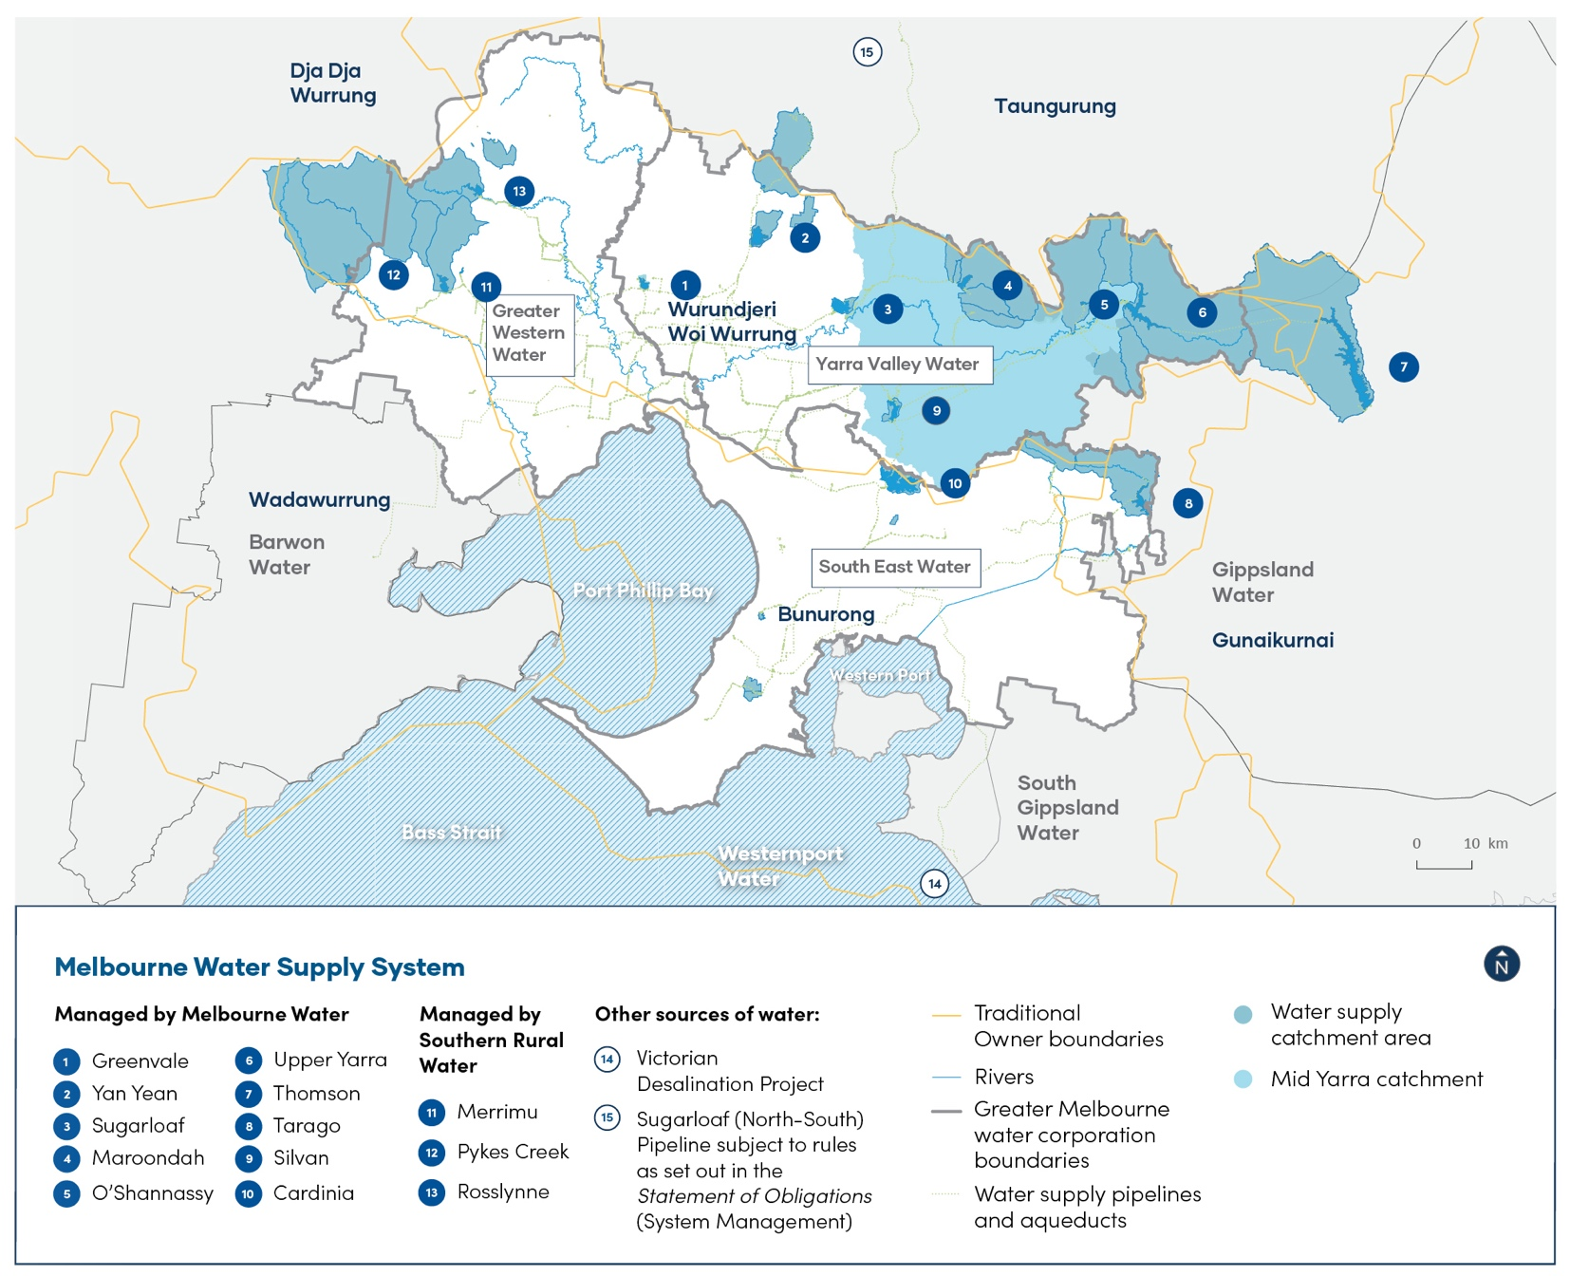

Drought and bushfires increase vulnerability of water supplies
Hotter, drier conditions raise bushfire risk, which can affect water quality and take reservoirs offline. Over half of Greater Melbourne’s drinking water comes from protected catchments surrounded by bushland – keeping it clean and great-tasting, but also vulnerable to fire. That’s why Melbourne Water carries out annual bushfire preparedness to protect these vital areas. Together with infrastructure upgrades we’re building a more resilient water supply system.

A connected system securing our water future
Over the past decade, Melbourne’s water supply system has become increasingly connected with neighbouring regions – known as ‘the water grid’. A better-connected system strengthens water security for Melbourne and the surrounding region, while supporting population growth and increasing demand.
Melbourne’s retail water corporations hold about 55% (745 billion litres) of the water in our storages. The remainder is held by other users, including regional water corporations, the Victorian Environmental Water Holder and Southern Rural Water for irrigators. This means not all water in storage is available to Melbourne's retail water corporations to supply customers. Some water isn’t accessed under normal conditions, to maintain the quality of our supply and the integrity of our infrastructure. This is known as minimum operating level (Figure 2).
Through the connected water grid, Melbourne Water also supplies regional water corporations including Barwon Water, Gippsland Water, South Gippsland Water and Westernport Water (Figure 1). Each of these organisations publishes its own Water Outlook, but we work together to consider their water use, alongside Melbourne’s needs, when planning for the future.
Our region continued growing with nearly 38,000 new households connecting this year across the Greater Melbourne region (Table 1).

Water in storage
Figure 2: Share of water held in Melbourne’s storages as at 1 November 2025.
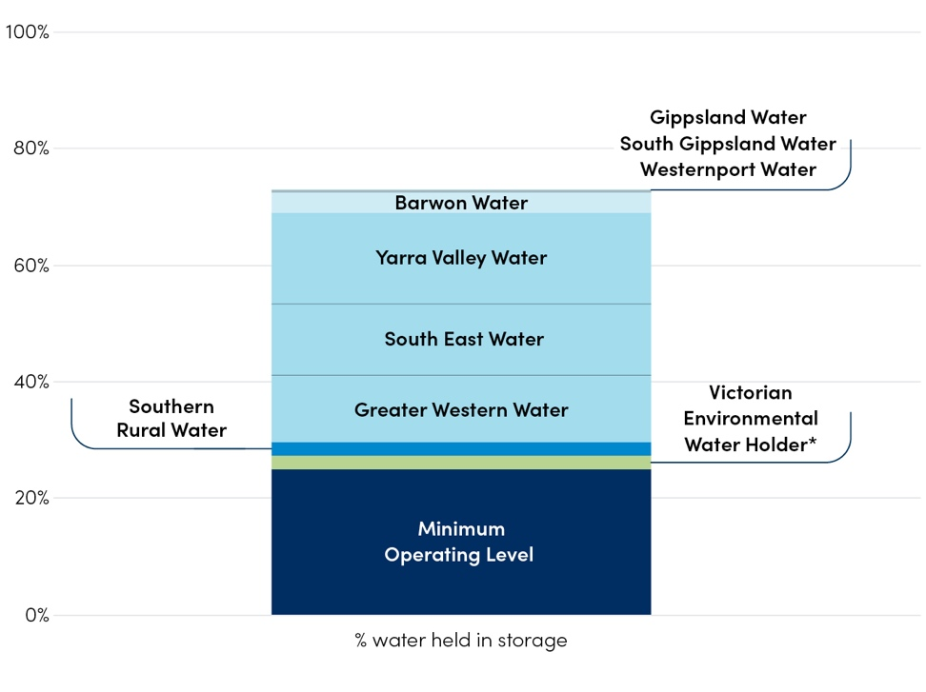
- Water inaccessible under normal operating conditions means access to this water is limited due to infrastructure constraints and there is an elevated risk to water quality or maintaining water transfers.
- The Victorian Environmental Water Holder is an independent body established by the Victorian Government responsible for holding and managing Victoria's environmental water entitlements.
Table 1: Melbourne water corporations new residential customer connections
Water corporation – residential connections | 2023/24* | 2024/25* | Increase
Greater Western Water | 583,127 | 598,825 | 15,698
South East Water | 774,079 | 783,591 | 9,512
Yarra Valley Water | 831,807 | 844,538 | 12,731
Greater Melbourne total | 2,189,013 | 2,226,954 | 37,941
The benefits of the water grid have been demonstrated this year, with warm, dry conditions impacting water supplies across the state. Connected regional water corporations are relying more on the Melbourne system to meet demand. (Table 2).

Volume of water supplied by Melbourne Water to each water corporation
Table 2: Volume of water supplied by Melbourne Water to each water corporation from the Melbourne water supply system in 2023/24 and 2024/25
Water corporation | 2023/24 (billion litres) | 2024/25 (billion litres)
Greater Western Water | 132.8 | 144.2
South East Water | 164.1 | 169.6
Yarra Valley Water | 166.8 | 177.0
Barwon Water | 2.5 | 11.3
Gippsland Water | 3.4 | 4.2
South Gippsland Water | 0.8 | 1.3
Westernport Water | 0.1 | 1.4
Total | 470.5 | 509

What water corporations are doing

Building a climate-resilient future through recycled water
By expanding recycled water infrastructure, South East Water is enabling a resilient and sustainable water future for communities and businesses across Melbourne’s south-east and the Mornington Peninsula.
The Dingley Recycled Water Scheme will play a big role in securing Victoria’s future water supply, unlocking an additional 1.8 billion litres of sustainable recycled water each year. The scheme is expected to bring recycled water to parks, world-class golf courses, sports ovals, laundromats, market gardens and nurseries.
Frankston City grounds will get greener with the 2.3 km Monterey Recycled Water Scheme. Delivering 98 million litres of Class A recycled water per year from Melbourne Water’s Eastern Treatment Plant, the scheme will support a thriving, more liveable community for locals and sporting clubs.
The Western Port Recycled Water Scheme will unlock 4 billion litres of Class A recycled water per year to agricultural areas in the south of Cardinia Shire. The project will help the bolster the region’s long-term water security and increase the growth of high value fresh vegetables and the availability and reliability of water supply for irrigated agriculture.
Plans are underway for circular water systems at Aquarevo (Lyndhurst) and Fishermans Bend, Australia’s largest urban renewal project. South East Water expects the Aquarevo Water Recycling Plant to treat 52 million litres annually and return Class A recycled water to homes for toilet flushing and clothes washing, reducing potable water use by up to 60%. An inner-city plant within Fishermans Bend will convert sewage from the Hobsons Bay sewer main into Class A recycled water, supporting a climate resilient, drought proof and sustainable community of around 80,000 people by 2050.
Major plant upgrades to South East Water’s Mount Martha and Lang Lang water recycling plants will also secure reliable Class A recycled water supplies, protecting the environment while supporting population growth.

2025 in review

Our water use
We saw water use increase in 2025, driven by a warm, dry climate and population growth.
Residential water use was 169 litres per person per day (Figure 3), which accounted for 65% of Melbourne’s total water use in 2024/25 (Figure 4). This is 3.5% higher than residential use in 2023/24 of 163 litres per person per day and the highest since 2006/07.
Alongside the increase in residential water use is an increase in water use by non-residential customers as well as non-revenue water. Total bulk usage in 2024/25 was above the Greater Melbourne Urban Water and System Strategy (GMUWSS) projections (Figure 5). Above average use is typical during periods when rainfall is low.
Given the increasing impacts of our growing population and climate change, it’s more important than ever that we continue to use water responsibly.
That means we should all aim to reduce our water usage to ensure that, on average, we're not using more than 150 litres per person per day.
Figure 3: Water use in Melbourne
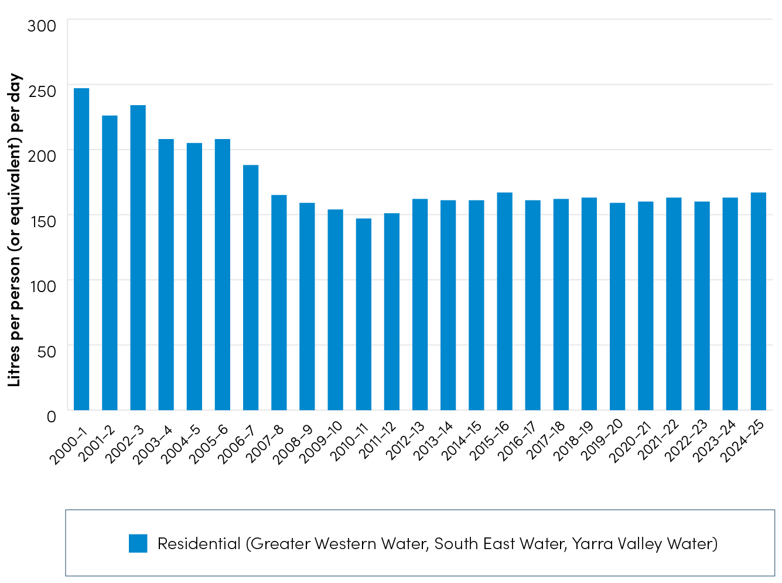
Figure 4: Water use breakdown across Melbourne for total non-revenue, non-residential and residential water. *Non-revenue water is water that is lost, stolen or given away without generating revenue.
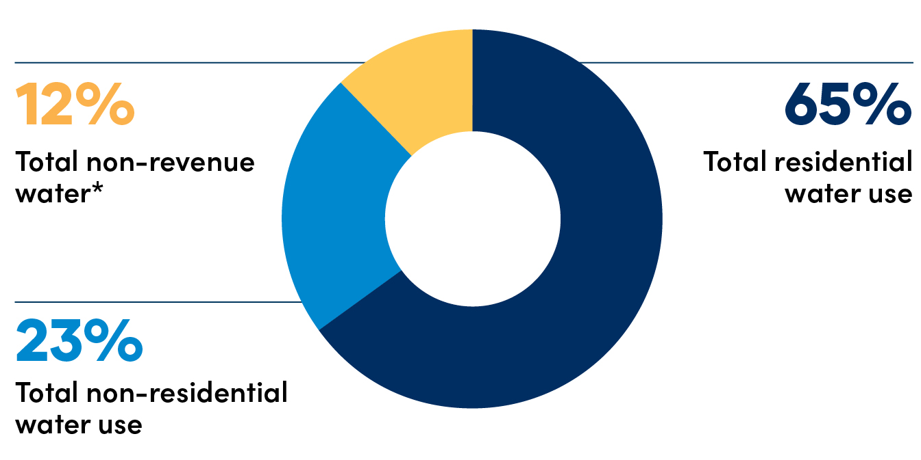

Rainfall and storages
In 2024-25, Melbourne experienced some of the lowest rainfall and inflows on record – similar to the worst years of the Millennium Drought. Inflows to Melbourne’s four major storages totalled 305 billion litres, around 36% below the 30-year average (Figure 6). This saw water in storage track along the dry and extreme dry year scenario from the 2024 Annual Water Outlook. As a result, Melbourne’s storages are now 13% (around 239 billion litres) lower than at the same time last year, due to a combination of very low rainfall, record-low inflows, and higher water use.
Figure 5: Melbourne’s annual potable water demand against Greater Melbourne Urban Water System Strategy projections.
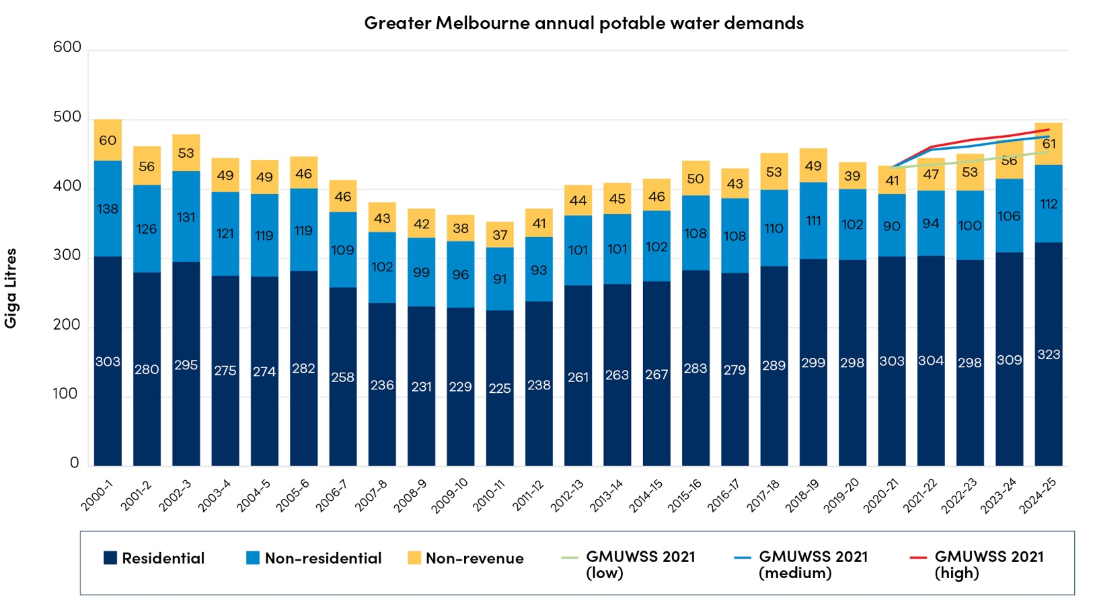
Figure 6: Comparison with 2025 Annual Water Outlook period
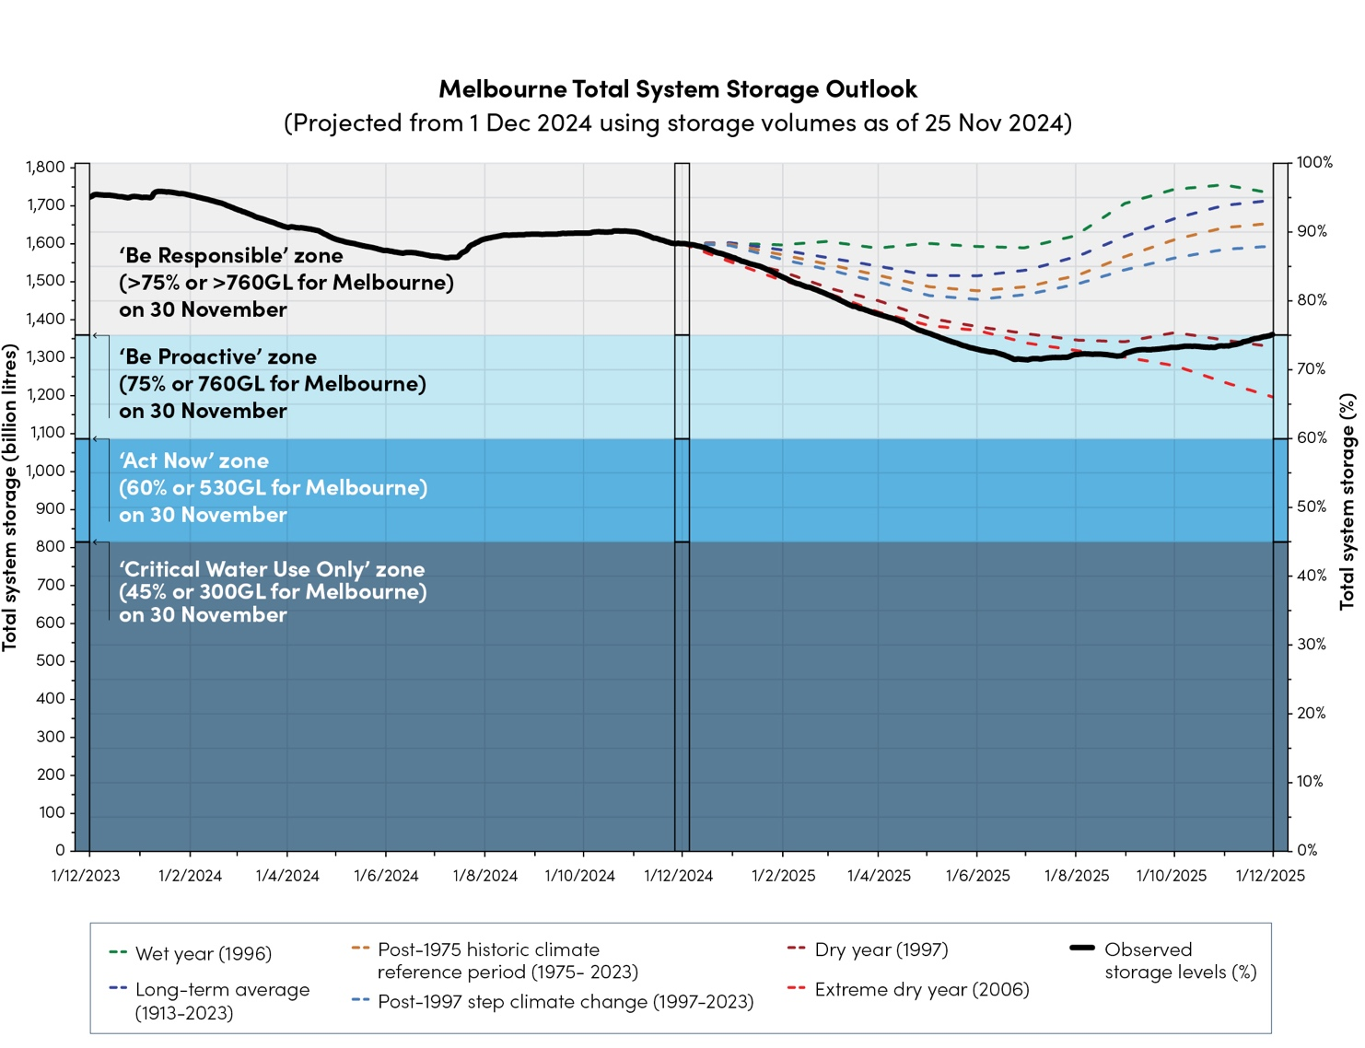
Note: Modelling reflects a 0 GL desalinated water order in 2024/25 and currently also assumes 0 GL in 2025/26.
Last Updated: 1 December 2025

How climate influences water storages
Victoria’s climate and streamflow is highly variable, but within this variability we’ve experienced a warming and drying trend over recent decades.
Victoria’s climate will continue to be variable with wet and dry years, against a background drying trend. With a warmer future and projections of declining water availability, we can expect more frequent and severe droughts in coming decades and increases in extreme rainfall events.
As of 27 November 2025, the Bureau of Meteorology (BoM) has announced that El Nino-Southern Oscillation (ENSO) outlook is currently in a La Niña state. While a La Niña event is underway, the latest BoM seasonal climate outlook for January - March 2026 shows a slightly higher chance of below average rainfall for the Melbourne catchments (Figure 7) and above 80% chance of exceeding median maximum temperature (Figure 8) across Melbourne.
Warmer weather usually leads to higher water use, particularly during summer, as outdoor watering of gardens, parks and sports grounds becomes more frequent.
Lower rainfall into storages over the long term and a growing population mean our storages can drop quickly.
Figure 7: Seasonal rainfall outlook for January to March 2026.
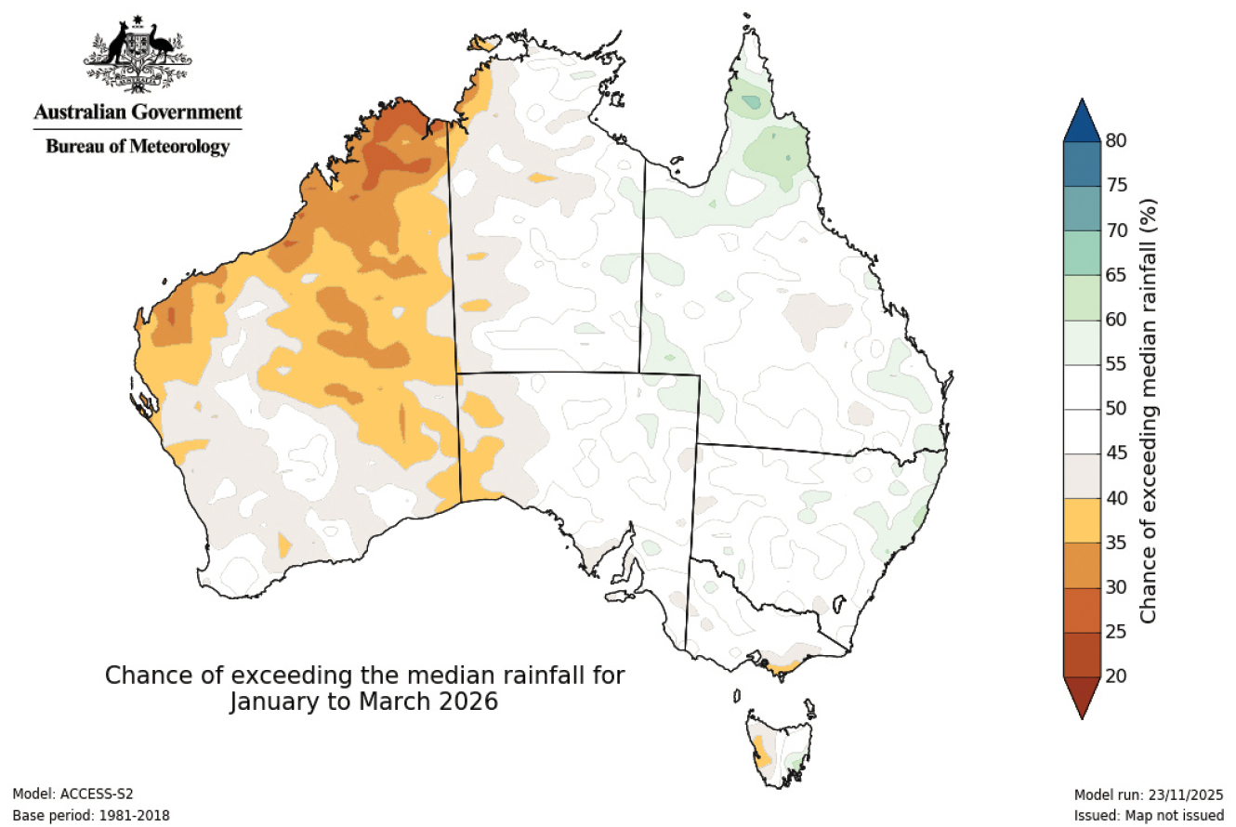
Figure 8: Seasonal temperature outlook for January to March 2026.
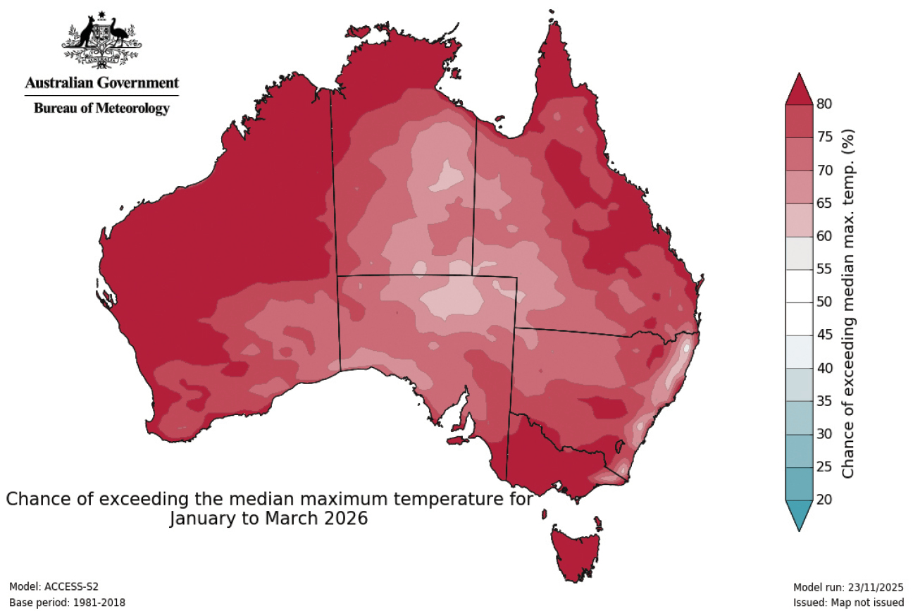

What water corporations are doing

Helping businesses save water through the WaterSmart program
Yarra Valley Water is helping businesses save water and money through the Victorian Government’s WaterSmart program.
The program provides digital water monitoring and audits to help eligible businesses that provide vital services to the community improve their water efficiency and reduce costs.
Since 2023, Yarra Valley Water has helped businesses save more than 80 million litres of water and over $420,000 off bills.
One example is Yarra Trams’ New Preston Depot, where data loggers detected unusually high water use in the tram wash backflush system. By adjusting the backflush cycle, the depot cut water use by almost 70 per cent, saving around 18,200 litres per day.
The WaterSmart program shows how simple, practical changes can deliver big savings for businesses while helping protect Victoria’s precious water supplies for the future.

The year ahead

Storage position
Melbourne’s storages have experienced a steep decline in the past 12 months, 13.2% or 239 billion litres lower than the same time last year. Storages are at 75.1% and 745 billion litres is available for Greater Melbourne (as of 30 November 2025). This means we are in the ‘Be Proactive’ Melbourne Water Outlook Zone.
Greater Melbourne's water security position is assessed and managed through the Water Outlook zones, which align to water held in storage and specifically, water available for Melbourne's retail water corporations. We consider total system storage and the volume available to Greater Melbourne when determining the Water Outlook zone we're in.
By 30 November 2026, storage levels could move between different Melbourne Water Outlook zones depending on rainfall and conditions (Figure 9):
- Around 40% chance storages will remain in the Be Proactive zone.
- Around 57% chance storages will return to the Be Responsible zone.
- In the event of continued extreme dry conditions - similar to the worst year of the Millennium Drought – storages could fall into the Act Now zone.
Keeping storages in the Be Responsible zone (above 75% or 760 GL for Melbourne) gives us a healthy buffer and greater confidence we can continue supplying Melbourne’s communities, even during dry or drought years.
This year we’ll take steps to boost storages, by using desalinated water and encouraging customers to make every drop count. We can order up to 150 billion litres of desalinated water each year – about 8% of our total storage – which can play a big role in slowing declines or helping storages recover.
However, if dry conditions persist, storages can fall quickly. If levels drop too far, water restrictions would almost certainly be required.
Current storage level: 75.1%
Volume for Greater Melbourne: 745 billion litres as of 30 November 2025.
Figure 9: Melbourne total storage system 2025–26
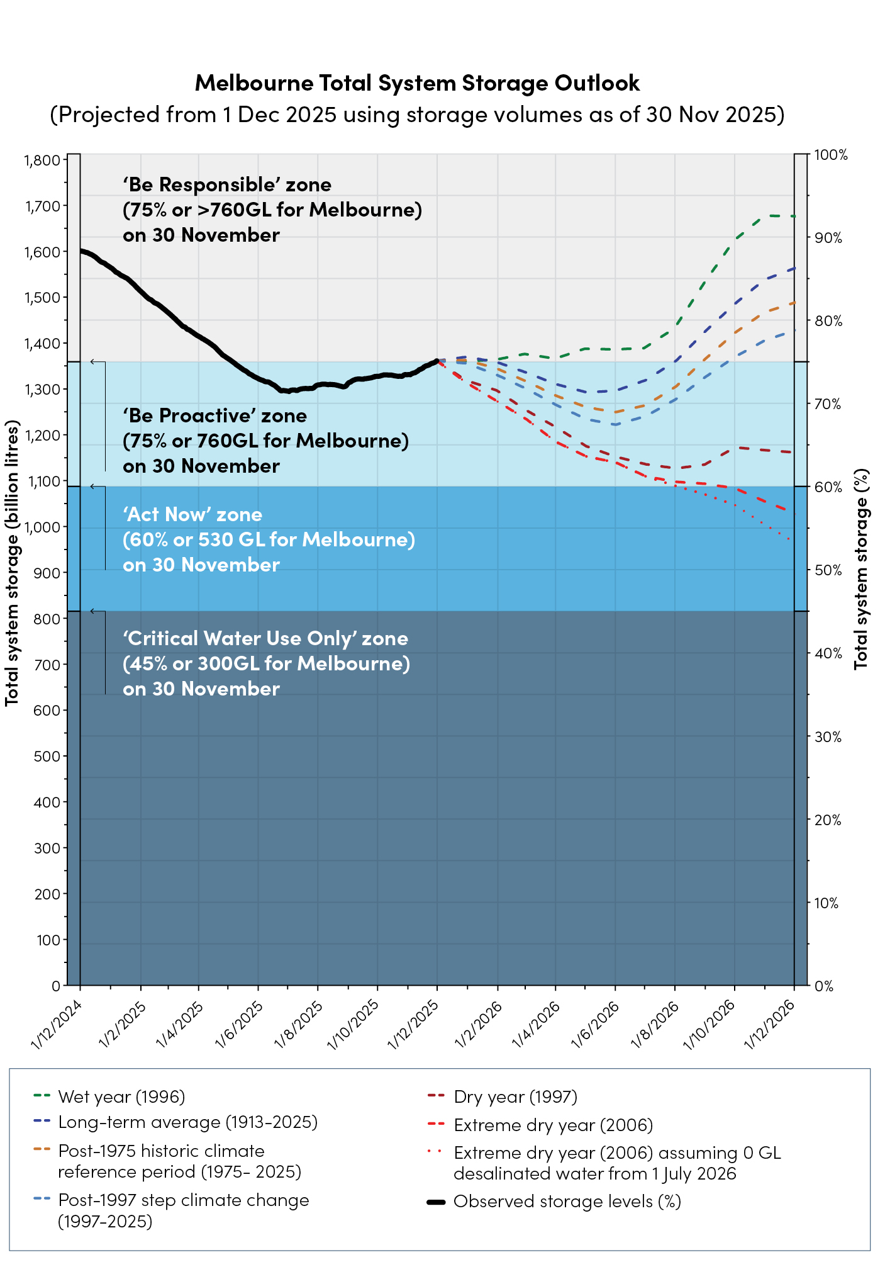
Notes: Desalinated water is assumed to be operational from 1 July 2026 (FY26/27) in the modelling.
Last Updated 1 December 2025.
Figure 10: Greater Western Water storage outlook 2025–26
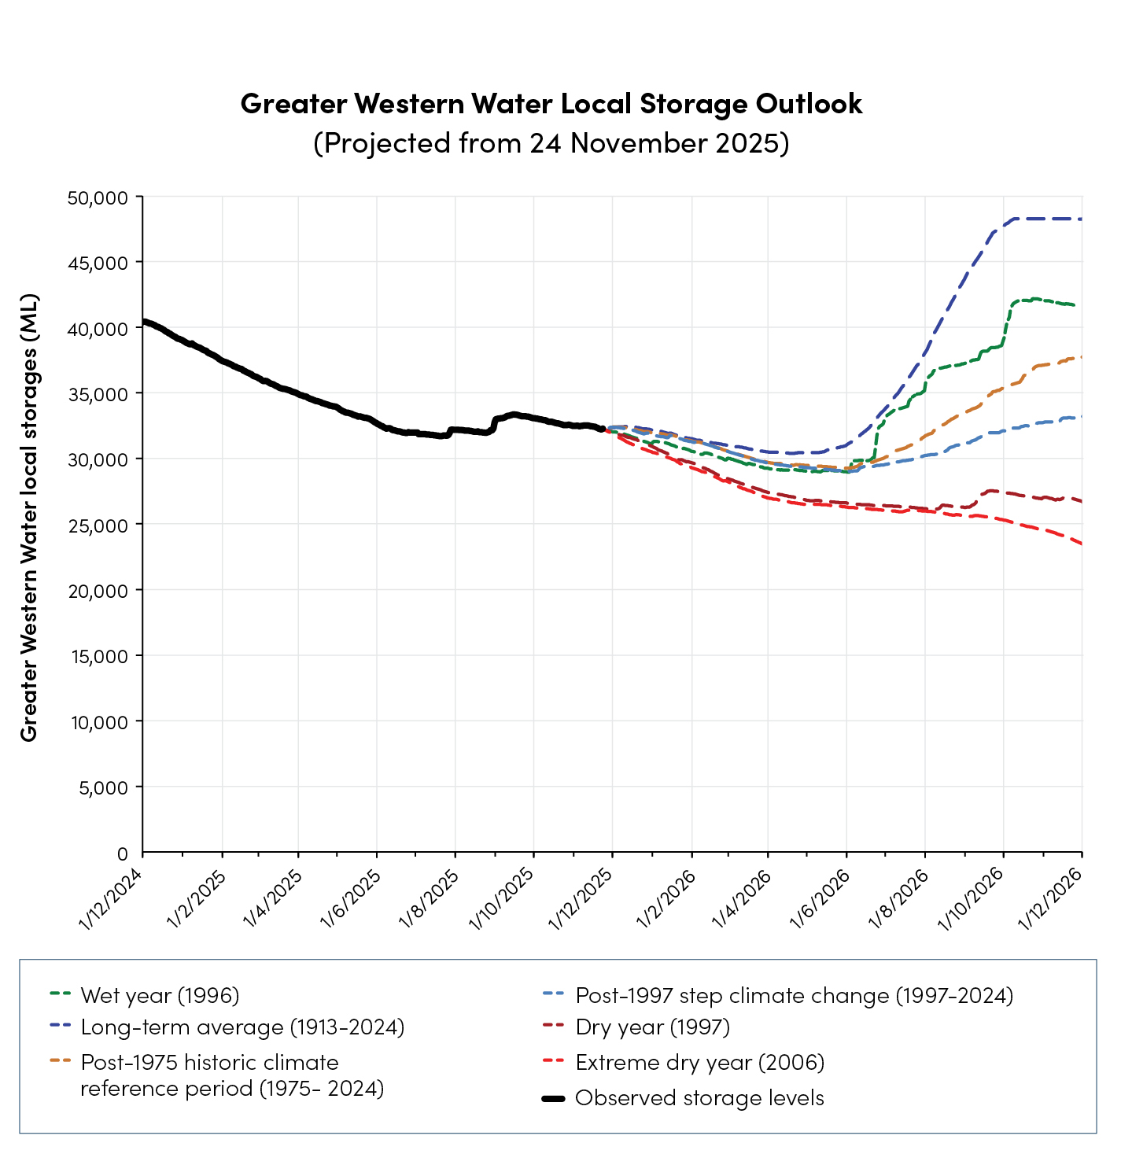
Drinking water in the northwest of the Greater Western Water service region comes from local creeks, reservoirs and bores (groundwater), supplemented by water from the Melbourne system.
Greater Western Water currently holds 31.3 billion litres in Merrimu and Rosslynne systems (Figure 10), which is not included in Melbourne’s total system volume (Figure 9). These local water supply systems help maintain a balance between water supply, storage buffers and consistency in water quality. Ensuring these areas have the same level of service as the rest of Melbourne is a priority for system operators.

What water corporations are doing

Recycled water for elephants supports sustainable water management and long-term resilience of our waterways
Greater Western Water completed a new 2.5 km pipeline project, connecting Werribee Open Range Zoo to recycled water produced at the Werribee Recycled Water Plant.
The $9.5 million project is now supplying the zoo with Class A recycled water for its new Elephant Trail, hippopotamus pool and irrigation for the zoo’s grounds.
Initially, the pipeline will deliver around 150 million litres of recycled water each year, with capacity to expand up to 400 million litres as the zoo grows.
The pipeline provides the zoo with a sustainable and reliable water supply by making beneficial use of treated wastewater that would otherwise be released into Port Phillip Bay. By reducing the zoo’s need to extract water from the Werribee River or using drinking water, the project also strengthens the long-term resilience of Victoria’s waterways.
This is a strong example of integrated water management in action, supported by $2 million in Victorian Government funding.

Likelihood of restrictions
We assess and manage Melbourne’s water security position against the Water Outlook Zones (Figure 11).
As of 30 November 2025, Melbourne’s water storages are in the ‘Be Proactive’ zone. The likelihood of restrictions in the next 12 months is Rare (1-4%)*. While we don’t expect restrictions in the next 12 months, Permanent Water Saving Rules rules will continue to apply.
The Be Proactive zone is a reminder to use water wisely and make every drop count, which helps reduce the chances of needing restrictions in the future.
We do this by continuing to talk to our community and customers to increase knowledge and awareness about water, by ordering desalinated water and by planning to make sure we have enough water in the future.
We’re also fortunate that large storages hold several years of supply for Melbourne and the connected regions when they are full. Dry conditions and falling storage levels are a good reminder that we need to be careful with our water resources. That’s why we’re asking Melburnians to ‘Make Every Drop Count’ through awareness and behaviour change campaigns.
Melbourne’s water corporations are committed to water conservation and efficiency– before considering water restrictions. This includes making sure we’re using water efficiently ourselves by finding and fixing leaks quickly and responding promptly to bursts.
Water restrictions are an important option for reducing demand and we expect they would have the biggest impact over summer when outdoor water use is typically higher. Moving to severe (stage 3 and 4) and prolonged water restrictions would impact the liveability and economy of our city and region and we work hard to avoid these whenever possible. Restrictions largely target outdoor water uses such as watering parks and gardens, refilling swimming pools, washing cars and other similar uses.
While restrictions mainly target outdoor use, there are big opportunities to save water indoors. Simple actions such as shorter showers, or installing water-efficient taps and appliances, can make a lasting difference. We also partner with the Department of Energy, Environment and Climate Action (DEECA) to deliver the WaterSmart program and Community Rebate Program.
Every year the Minister for Water places an order for up to 150 GL of desalinated water. The volume available from desalination is the greatest contribution that can be made in a single year to boosting water storages, significantly greater than the potential savings from severe water restrictions.
We also work with customers and communities to build knowledge about water, encourage everyday savings, and plan for the future to make sure Melbourne has a secure supply.
If we experience continued dry conditions and higher water use through 2026, resulting in further storage decline, restrictions will more likely be required over summer 2026/27. Although restrictions are unlikely this year, extreme events, emergencies or unavoidable system issues can occasionally make them necessary.
We're always monitoring storage levels and we know water is front of mind for many people. We'll keep our customers and communities informed through our websites and social media. While dry conditions continue, this will include an Annual Water Outlook Update at the end of each season - in early March, June and September. Each update will include an overview of system storage levels, customer water use and the likelihood of restrictions.
Water restrictions mainly limit how water can be used outdoors, such as in your garden. If restrictions were needed in the future, they wouldn’t save as much water as they did during the Millennium Drought. That’s because today our homes are generally bigger, but our gardens are smaller – so we already use less water outdoors.
That’s why it’s important to keep looking for ways to use water efficiently every day, both inside and outside home.
* Likelihood of Restrictions ratings: Very Rare <1%; Rare 1-4%; Unlikely 5-19%; Possible 20-49%; Likely 50-79%; Almost Certain 80-100%
Figure 11: Water outlook zones
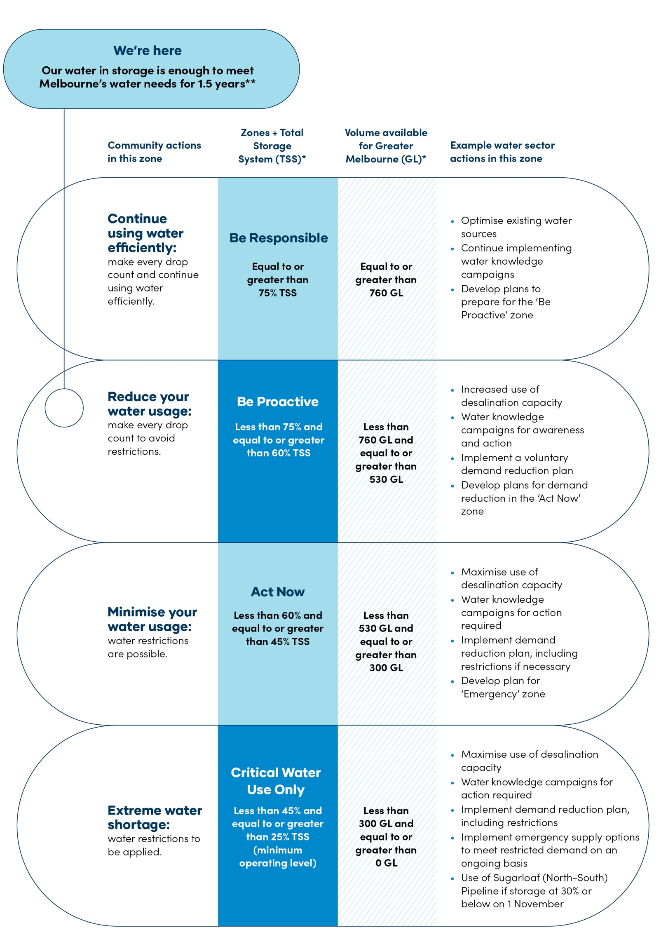
* In the event of different zones being indicated by Total System Storage and Water Available for Greater Melbourne at 30 November, the lower zone shall apply.
** Based on 2024/25 water use of 491GL and 745GL of water in storage for Greater Melbourne.

Greater Western Water – northwestern supply network and likelihood of restrictions
A description of local drinking water supply systems in the northwest of the Greater Western Water service region is provided below. Water restrictions may be needed at different times than Greater Melbourne, for some towns, due to local storage levels or operational constraints.
Table 3: Summary of the Annual Water Outlook for Greater Western Water’s local systems
Supply system | Towns supplied | Sources of supply | Likelihood of water restrictions in the next 12 months | Summary of the system operation and supply measures
Romsey - Lancefield | Lancefield  Romsey | Garden Hut, Kerrie, Forster, Wright Reservoirs, groundwater, Rosslynne Reservoir, Melbourne system | Rare | Water is supplied from local reservoirs and groundwater sources. Transfers from the Rosslynne / Melbourne systems are expected under most conditions in particular during summer.
Myrniong | Myrniong | Pykes Creek Reservoir | Rare | Myrniong system receives supply from Pykes Creek Reservoir.
Rosslynne | Sunbury  Diggers Rest Bulla  Gisborne  Macedon  Mt Macedon  Riddells Creek | Rosslynne Reservoir  Melbourne system | Rare | Sunbury and surrounding small towns are supplied directly from the Melbourne system. Gisborne, Macedon, Mt Macedon and Riddells Creek are supplied from Rosslynne Reservoir during summer and from the Melbourne system over winter.
Merrimu | Melton  Bacchus Marsh  Eynesbury  Rockbank  Toolern Vale  Long Forest | Merrimu Reservoir  Melbourne system | Rare | Melton and surrounding small towns are supplied from the Melbourne system. Bacchus Marsh is supplied from Merrimu Reservoir.
Woodend | Woodend | Campaspe Reservoir C, Graham Brock and Mt Macedon Reservoirs, Rosslynne Reservoir, Melbourne system | Rare | Woodend receives water from local reservoirs. Transfers from the Rosslynne / Melbourne systems are expected under most conditions in particular during summer.

Securing Melbourne’s water future
Melbourne continues to grow with nearly 38,000 new household connections in the past year – and this growth is set to continue. To support current and future growth, the Victorian Government’s Housing Statement commits to building new homes and connecting them to essential services more efficiently.
As both our population and water needs increase, sustained investment in infrastructure and planning is critical to ensure new communities have reliable access to water and other essential services.
A booming population, variable climate and rising demand all shape how we plan for the future. To manage these pressures, we work with communities, customers, Traditional Owners and government partners to make sure our strategies reflect the many voices of the region.
Our long-term planning is guided by a suite of strategies and plans that hold us accountable through regular reporting and delivery of actions:
- Annual water outlooks – released each December to outline the actions we may need to take over the next 12 months to secure Melbourne’s water supplies.
- Drought preparedness plans – developed by each water corporation to set out the steps we’ll take to ensure communities are ready if drought occurs.
- Central and Gippsland Region Sustainable Water Strategy (CGRSWS) – led by the Victorian Government, this strategy balances the needs of urban communities, irrigators, Traditional Owners and the environment across the Central (including Melbourne) and Gippsland region. It sets the strategic direction and policies needed to secure the region’s long-term water supplies. Read more about the CGRSWS.
- Greater Melbourne Urban Water & System Strategy (GMUWSS): Water for Life – sets out how Melbourne’s water corporations will work together over the next 50 years to maintain high-quality supplies for a growing city, identifying scenarios and options to address future challenges. Find out more about the GMUWSS.
- Water Security Plan for Greater Melbourne, Geelong and connected towns – outlines a range of potential options to cater for future water demands across the region. It will investigate how to increase water efficiency, use more stormwater and recycled water for non-drinking water purposes, upgrade recycled water to make it drinkable and potential expansion of desalination.
Melbourne’s water corporations have begun working on their next Urban Water Strategies, which will be finalised in 2027. These strategies will build on our combined Greater Melbourne Urban Water & System Strategy: Water for Life to ensure we can continue delivering secure water services to Melbourne and connected regions.

What water corporations are doing

Strengthening Melbourne’s water security

Mount Evelyn Water Treatment Plant
Melbourne Water is investing in the future of our city’s water supply with construction underway of a new back-up water treatment plant in Mount Evelyn. This vital infrastructure will help ensure safe and reliable drinking water for millions of Melburnians – especially during emergencies or maintenance at the Silvan Reservoir Water Treatment Plant. Silvan Reservoir currently supplies over half of Melbourne’s population.
The site was carefully selected for its proximity to Silvan and existing underground water mains.
Construction is expected to be completed by early 2027. The project is a proactive step toward a more resilient water supply system - keeping taps flowing as more people call Melbourne home, and as we prepare for the challenges of tomorrow.
Mount Evelyn Water Treatment Plant | Melbourne Water

How we’re tracking against our actions
See the below summary of our activities towards delivering the Minister’s expectations and priority actions in the GMUWSS.

Priority Action | Timing | Status | Update
Overcoming our challenges
2.1 Enhance our understanding of water use to improve short, medium and long-term water use projections. | Short term (2027) | On track | We continually improve our understanding of water use in our systems and look for fit-for-purpose alternative supplies.
2.4 Take a leadership role in the industry shift towards a circular economy and enable greater use of recycled water and a mix of centralised and decentralised solutions. | Short term (2027) and ongoing | On track
Ensuring a secure and sustainable water future
4.1 Develop and deliver a joint Water Efficiency Plan increasing our focus on water conservation and efficiency to provide cost-effective water savings. | Short term (2023) and ongoing | On track | We continue to progress readiness activities consistent with the Victorian Government’s Water Security Plan to ensure we can supply Melbourne’s water needs now and into the future.  Options include:  - enhancing and expanding our existing system (including new manufactured water sources, like desalination and indirect purified recycled water)  - integrated water management (including using recycled water and stormwater for non-drinking uses, to reduce demand on our drinking water supplies)  - water efficiency (including finding ways to use less water in our homes, businesses, communities, and distribution networks).
4.2 Support the development of IWM action plans to support delivery of the catchment scale IWM plans. | Short term (2023) and ongoing | On track
4.3 Engage with customers on the feasibility of using all source options across Melbourne to supplement drinking water supply and undertake studies and trials to demonstrate efficacy. | Short term (2026) and ongoing | On track
4.4 Lead transition of the Melbourne system towards more manufactured water for our region. | Short term (2023) and ongoing | On track
4.5 Lead the planning and delivery of options for potential augmentations outlined in the Adaptive Plan pathways, including the commencement of readiness activities on near-term options. | Short term (2023) and ongoing | On track
4.6 Plan and operate the existing water supply system to optimise water availability and be prepared to manage supply emergencies and droughts. | Short term (2023) and ongoing | On track
4.7 Develop and utilise clear project assessment and investment frameworks to support deliver of the GMUWSS Water Security Framework. | Short term (2023) and ongoing | On track
Water for Traditional Owners and the environment
5.5 Support the intent of the CGRSWS to return water to Traditional Owners and the environment. | Short term (2023) and ongoing | In progress | We’re working with the Victorian Government to support and enable the return of water to Traditional Owners and the environment.  We’ve started work on the important commitments outlined in CGRSWS to identify opportunities to return water to Traditional Owners, remove barriers to water ownership and strengthen the role of Traditional Owners in water planning and management.  Through genuine partnerships with Traditional Owners, we’re committed to working together to maintain and improve the health of Country and support self-determination.
Healthy environment and waterways
6.1 Deliver environmental flow targets to ensure ongoing waterway resilience. | Short term (2023) and ongoing | On track | We continue to progress stormwater priorities in the Healthy Waterway strategy, IWM action plans and delivery of CGRSWS.  We’re assessing the ongoing role that stormwater plays in fit-for-purpose use in our region. This includes consideration of large-scale stormwater harvesting schemes.  During 2024–25, 34 GL of water for the environment was delivered in the Thomson, Yarra, Tarago, Maribyrnong and Werribee rivers. The releases meet priority watering actions to ensure protection of rivers along with the plants and animals that rely on them.
6.2 Lead system-scale stormwater management by planning for investment in and management of large-scale stormwater projects. | Short term (2025) and ongoing) | On track
6.5 Investigate the whole of life cycle performance of rainwater and stormwater harvesting assets, and how to increase their effectiveness, affordability and compliance. | Short term (2027) | In progress
6.6 Investigate stormwater and recycled water options for irrigation customers and unlock supplies to other users in growth areas and on the peri-urban fringe. | Short term (2027) | On track
Partnerships, engagement and education
7.3 Engage with the community on the ‘true value of water’ to empower our community in decision making. | Short term (2023) and ongoing | On track | Each year the metropolitan water corporations collaborate on a range of water conservation, literacy programs and community engagement to promote collective action, highlighting to customers that if we each save a little, we all save a lot.

What water corporations are doing

Helping schools detect leaks and save water and money
Water corporations are delivering the Victorian Government funded Schools Water Efficiency Program (SWEP), which is helping 857 schools across Melbourne detect leaks and save water and money. The program equips schools with data logger technology, allowing them to track and monitor their water usage in real time. This not only helps schools reduce their water consumption but also educates students about the importance of saving water both at school and at home.
In 2024/25, participating schools across Greater Melbourne saved over 429 million litres of water and $2.25 million. Since the program’s launch in 2012, around 6.4 billion litres of water and $26.7 million has been saved.

How you can make every drop count
We all have a role to play in securing Melbourne’s water future. By making small changes every day, we not only save water but also reduce our household bills and help protect our environment.
Here’s what you can do:
- Follow the Permanent Water Saving Rules set by the Victorian Government – these are simple, everyday habits that make a big difference.
  - Always water your garden using a leak-free hose with a trigger nozzle
  - Sprinklers and drippers can only be used before 10 am and after 6 pm
  - Don't hose concrete, paths or driveways - use a broom instead
  - Fountains and water features must recirculate water
- Look for extra ways to save water at home and in the garden, such as shorter showers, turning off the tap while you brush your teeth, using mulch in the garden and fixing leaks quickly.
- Stay informed. Follow us on social media for regular updates on water-saving tips, current storage levels, and long-term plans to keep Melbourne’s water secure as our city grows.
Together, these small steps add up. If every household saves a little, the whole community saves a lot – helping to keep water available for everyone, now and into the future.

